My 'Wheel of Life' Activity
Step I (A Day in My Life)
Write dowm various tasks and activities you perform in a typical day of your life on the basis of the last 12 months.
____________________________________________________________________________________________________________________________________________________________________________________________________________________________________________________________________________________________________________________________________________________________________________________________________________________________________________________________________________________________________________________________________________________________________________________________________________________________________________________________________________________________________________________________________________________________________________________________________________________________________________________________________________________________________________________________________________________________
Step 2
On the basis of 'A Day in My Life' suggested earlier, plot my wheel of life'. Consider the wheel as a typical day or a week. Plot the size of the angle on the basis of the time spent on the activity in a typical day or week.
My Wheel of Life

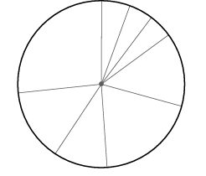
Step 3
Now, look at the EI fuel balance. How much EI fuel do you generate and consume? Remember that adequate sleep, mental gym/ meditation, physical activity and balanced food and nutrition are the aspects that generate this fuel. The rest of the activities just burn EI fuel. Summarize the emotional fuel balance you have on a given day
My El Fuel Balance: Action Plan
List down the key actions that you would initiate to convert your EI fuel balance.
______________________________________________________________________________________________________________________________________________________________________________________________________________________________________________________________________________________________________________________________________________________________________________________________________________________________________________________________________________
Step 4: Exchange
Exchange your thoughts and experiences with people you trust on the basis of your BI fuel balance
Discuss the following questions:
- In which of the activities do I gain El fuel?
- Which are the activities that burn my El fuel?
- What are the specific actions that I must take to change the balance to more positive?
- What are the activities I must preserve or further strengthen?

